InsideSUPRA, the full Windows 11 braille tablet.

USER MANUAL

Insidevision – v.4.0_03-25

Contents

Let’s begin 5

What is in the Box? 5

What is insideSUPRA? 6

insideSUPRA Technical Specifications 6

Description of the insideSUPRA 6

Left Side 7

Right Side 7

Orientation to the bottom panel of insideSUPRA 8

insideSUPRA Braille Keyboard 9

The Zones 10

Placement of the Left Hand on the braille keyboard 10

Placement of the Right Hand on the Braille Keyboard 10

Insertion and Removal of a Micro SD Card 11

Let’s use it 12

Starting up and shutting down 12

Turning on the insideSUPRA 12

Shutting down insideSUPRA Using the Windows Desktop 12

Shutting down insideSUPRA Using the Control icon on Windows desktop 12

Sleep Mode 13

Hibernate 13

Interacting with the insideSUPRA 13

Using the keyboards available with insideSUPRA 14

The Braille Keyboard 14

Different functions for different zones 15

The tables below show the various functions by zone 16

Choosing Braille grades 18

Choosing a braille grade in Home 18

Choosing a braille grade when NVDA is enabled 18

Choosing a braille grade with JAWS 18

The Braille HID (Human Interface Device) keyboard 18

Braille shortcuts 18

What is the Alphanumeric Transcription Bar? 19

The Home environment 20

Objects 20

What are objects? 20

Parent-Child Objects 20

Prefixes and Suffixes 20

Moving focus and Braille reading 20

Using the Note application within the Home Environment 21

Moving Between Objects of a different Type 21

Home menu items 23

Explorer. 23

Example: 23

Navigation: 24

The Run menu in Explorer 25

The Pop menu in Explorer 25

Note. 25

The Run menu from Note 26

Calculator. 30

Summary of functions and keyboard shortcuts 34

Switch. 36

Settings. 37

Control 37

insideSUPRA boot up process options 38

Windows 38

NVDA 38

JAWS 39

Special Desktop Icons 39

Technical Support and Troubleshooting Your Tablet Remotely 41

Password of the insidevision session 41

Remote Assistance 41

Care and Maintenance of insideSUPRA 42

Appendix F: NVDA shortcuts 43

Single-pressed keyboard keys 43

Direct shortcuts 45

Appendix G: JAWS shortcuts 48

Single-pressed keyboard keys 48

Appendix H: HOME suite keyboard shortcuts 51

Appendix I: HID keyboard shortcuts 53

Single-pressed keyboard keys 54

HID keyboard direct shortcuts 55

# Let’s begin

## What is in the Box?

Carefully unbox the insideSUPRA making sure to keep the original packaging, as it can be used to transport your insideSUPRA in the future.

avec une confiance moyenne

The box contains:

* The insideSUPRA tablet
* An AC adapter with the following specifications: AC 100-240V 1.5A 50~60Hz
* A USB-C cable to connect one end to the AC adapter and the other end to the left USB-C port of the device for charging.
* A Carrying case with a strap.

## What is insideSUPRA?

The insideSUPRA is a Windows 11 tablet computer with an integrated high-quality 32-cell refreshable braille display. A proprietary Home application along with a Windows screen reader (NVDA and/or JAWS) are preinstalled, so that the tablet will boot up with speech. The preinstalled copy of JAWS is licensed for 40 minutes only.

All this is integrated into an aluminum to which we've added a 10-key Braille keyboard, an 8-key shortcut command keyboard, and a 5-action joystick for 100% qwerty keyboard function.

## insideSUPRA Technical Specifications

The tablet’s 16GB of RAM, and quad-core Intel i7 processor clocked at 1.2 GHz (up to 4.50 GHz in Turbo) allow the insideSUPRA to boot up quickly. The insideSUPRA has a 256 GB SSD NVME compatible drive with the ability to expand storage capacity by an additional 1TB GB using a Micro SD card. In option, you can choose 512 GB or 1TB SSD drive. Wi-Fi supports 802.11a/b/g/n connection standards; however, only the 5 GHz band is supported for 802.11n. The device also supports Bluetooth® 4.1. The tablet's 5850mAH battery can provide up to 7 hours of usage, and up to 200 hours on standby. The insideSUPRA also has 2 built-in microphones, and stereo speakers of 2W each.

## Description of the insideSUPRA

The insideSUPRA resembles an off-the-shelf Windows tablet with the addition of a 32-cell braille display. All components are contained within an anodized aluminum shell. There are 8 specific function keys above a physical Braille keyboard, plus a 5-action joystick at the lower right of the keyboard. There are 32 routing cursors and a 32-cell braille display with 2 scroll keys. The following sections will help orient a user to the insideSUPRA.

### Left Side

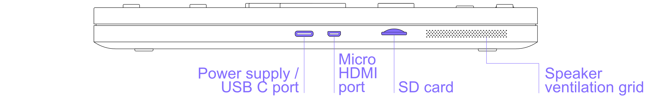

Along the left side of the insideSUPRA starting closest to the braille display and moving away from it, you have a Micro SD card slot, a Micro HDMI port, and a USB C port for charging the unit.

### Right Side

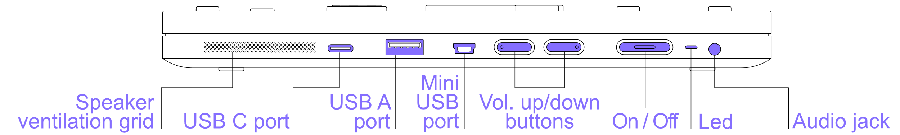

Along the right side of the insideSUPRA starting closest to the braille display and moving away from it, you have a USB C and a USB-3 ports to connect a USB stick or another peripheral, a mini USB port, the Volume Down button, the Volume Up button, an LED indicator which is red while the tablet is charging, and stays red once charging is complete, the Power button and a 3.5 mm audio jack. There are no ports or controls on the front or back side of this device.

### Orientation to the bottom panel of insideSUPRA

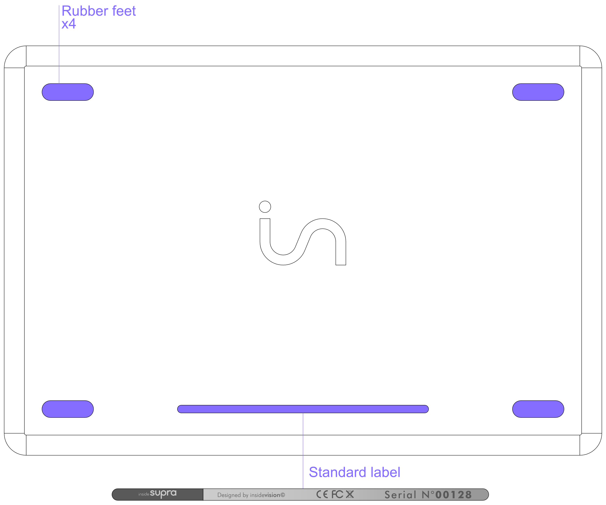

There are four rubber feet on the bottom of the insideSUPRA to keep it stable, and to prevent it from sliding around when in use. Between the two rubber feet nearest the braille display is a printed label with the serial number, electrical information, and standards with which the insideSUPRA complies.

### insideSUPRA Braille Keyboard

For proper orientation to the insideSUPRA, please place it on a flat surface with the braille display closest to you. There are ten oval-shaped physical keys. These correspond to the eight dots on a braille display's keyboard with the addition of two space keys.

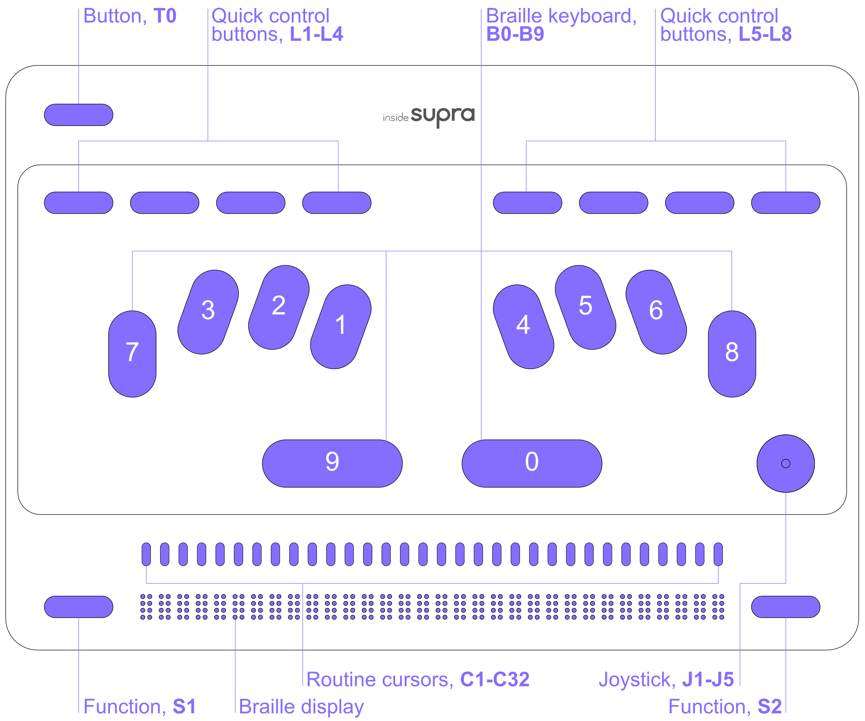

### The Zones

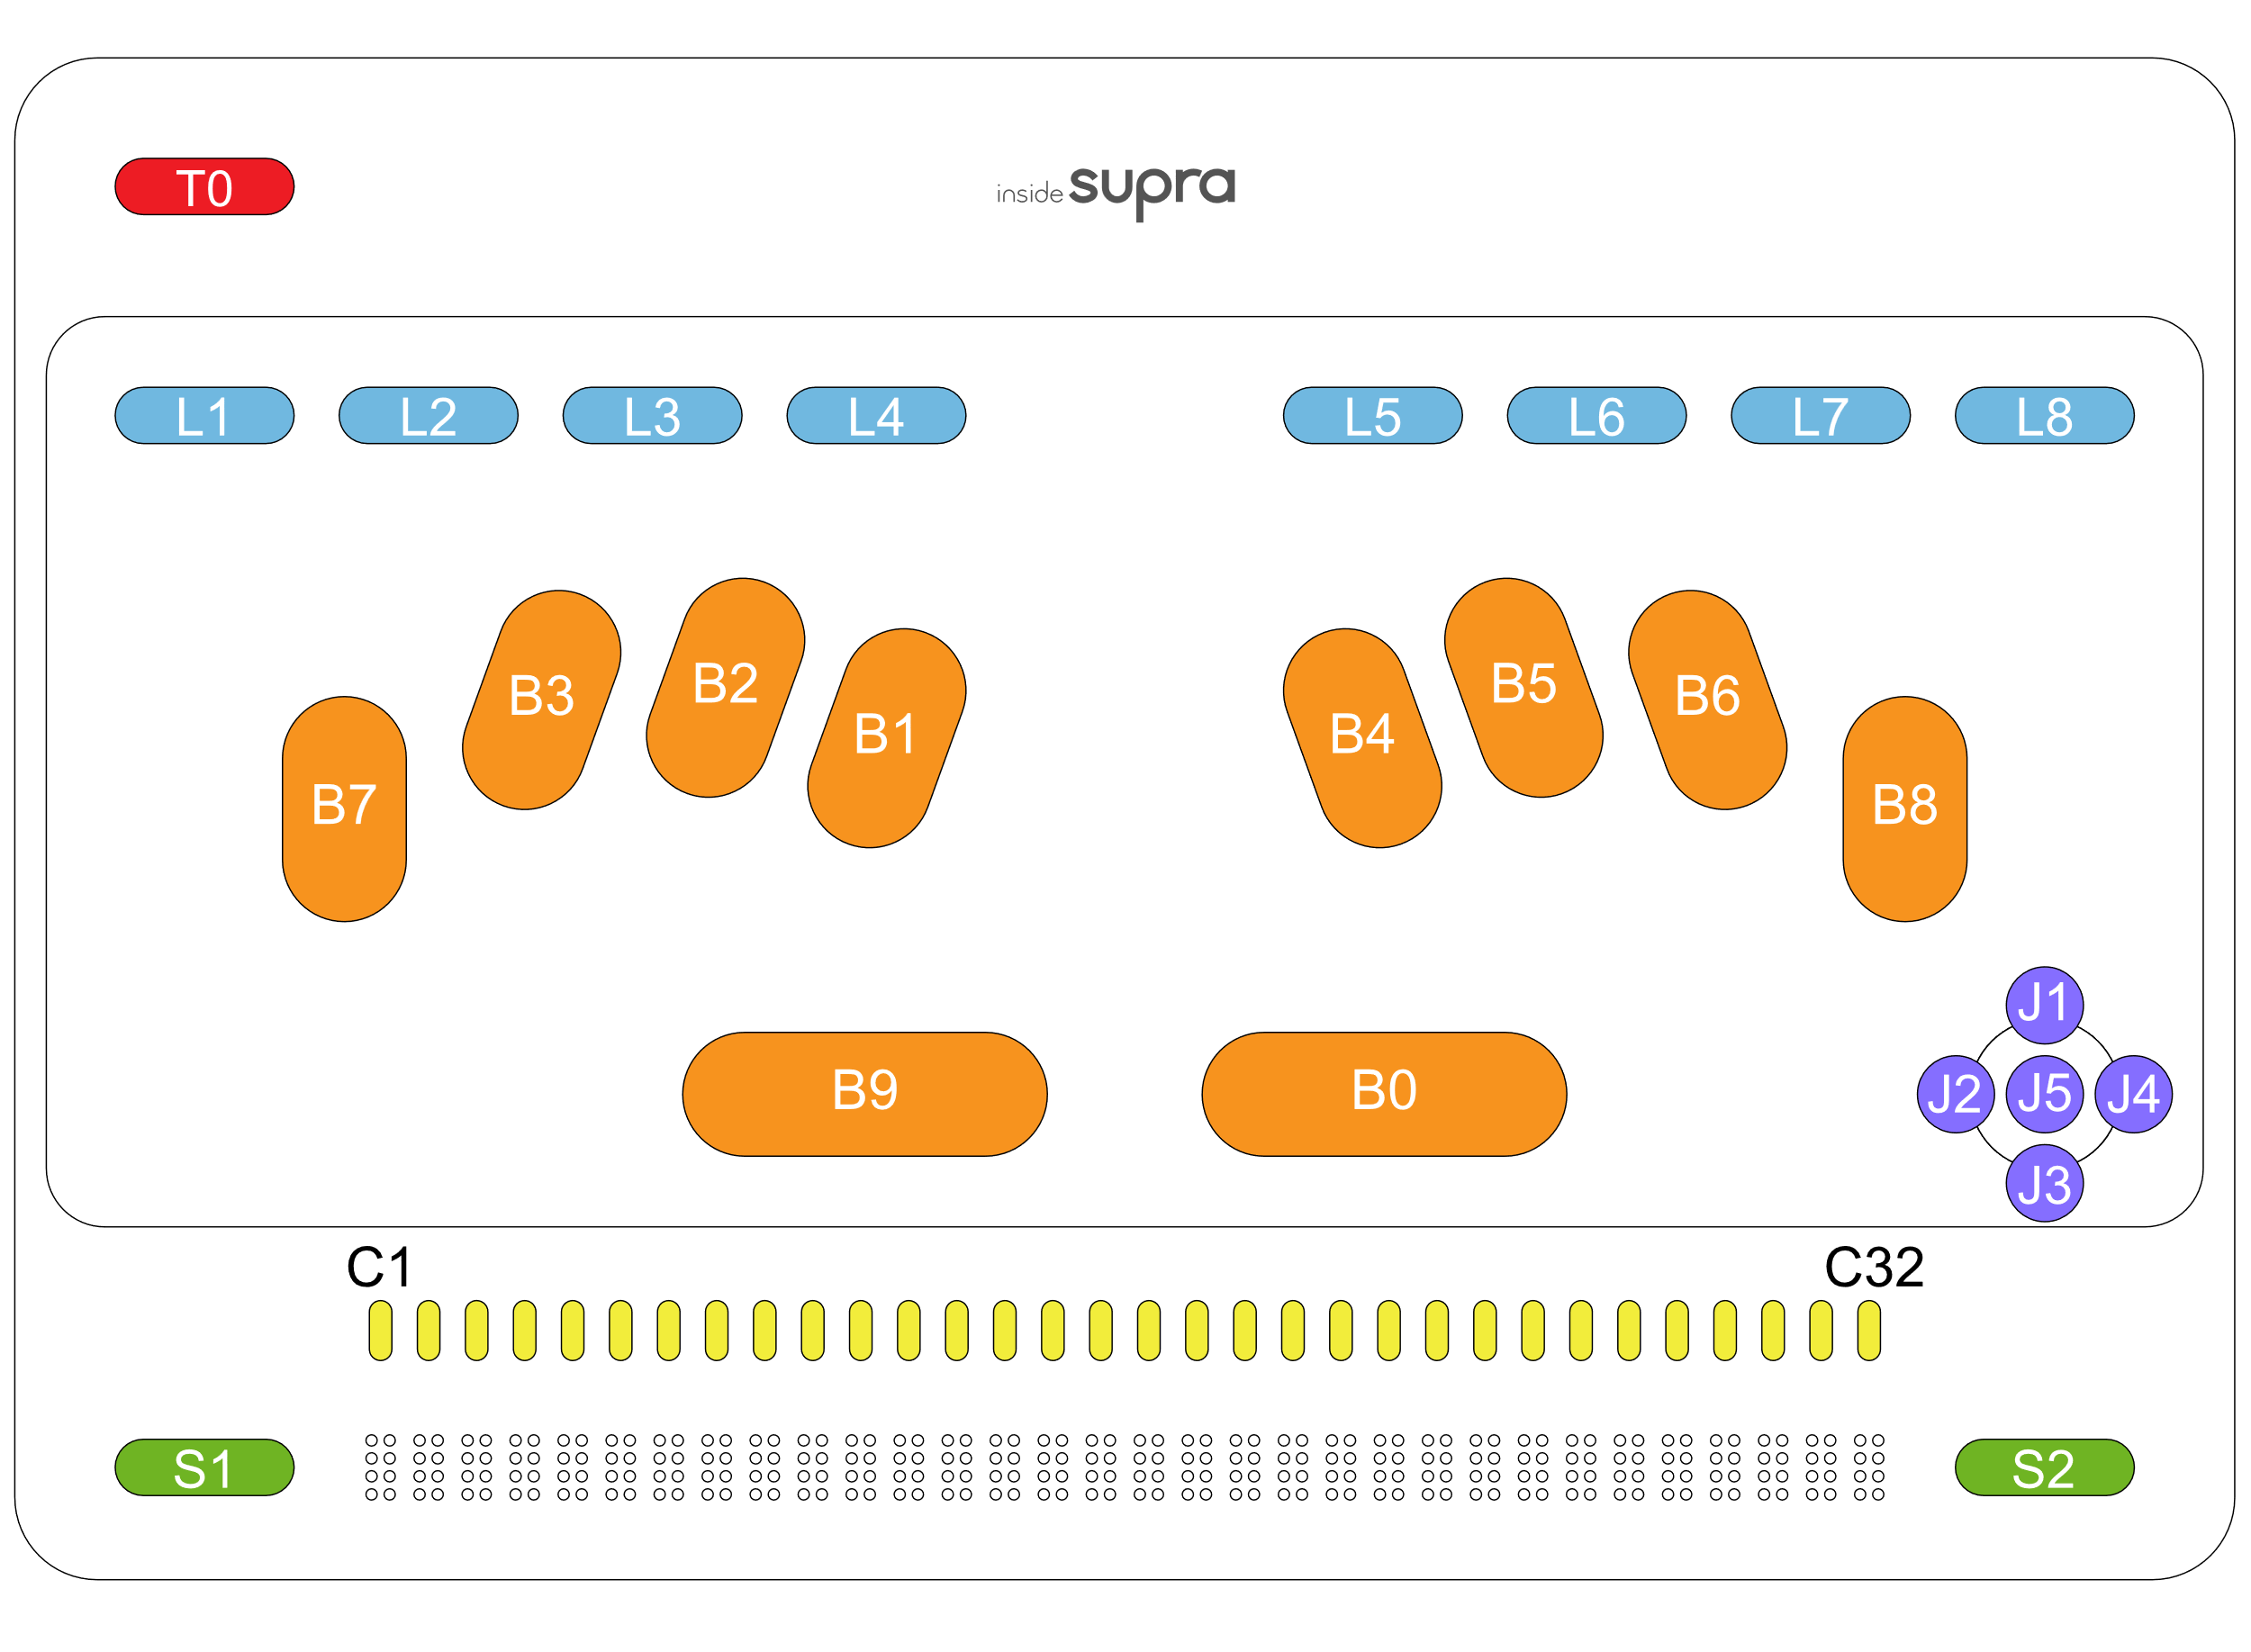

Starting from the bottom, you'll find the 32-cell Braille display, as well as the function key named S1 on the left and the S2 function key on the right. These are the panning keys.

As you move upwards, your hands come to rest on the routine cursors named C1 to C32.

As you move upwards with your hands towards the center, you'll come across 2 horizontal keys, named key 9 and key 0.

### Placement of the Left Hand on the braille keyboard

If you have placed your hands correctly, from left to right you have the following keys. Dot 7 is under the little finger of your left hand, dot 3 is under your ring finger, dot 2 is under your middle finger, and dot 1 is under your index finger. Your left thumb will rest on the left Space key, also known as key 9. This horizontal oval-shaped key is directly under dots 1 and 2.

### Placement of the Right Hand on the Braille Keyboard

Your right thumb will rest on the second Space key, also known as key 0. This horizontal oval-shaped key is directly under dots 4 and 5. Dot 4 is under your right index finger, dot 5 is under your middle finger, dot 6 is under your ring finger, and dot 8 is under your little finger.

At the same height, on the right is a joystick with 5 actions named J1 to J5.

Raising both hands above the Braille keypad, you'll find the 8-key shortcut keypad, with the L1 L2 L3 L4 keys to the left hand, starting from the edge of the device, and the L5 L6 L7 L8 keys to the right hand.

Moving up above the keypad on the left, you'll find the T0 Button.

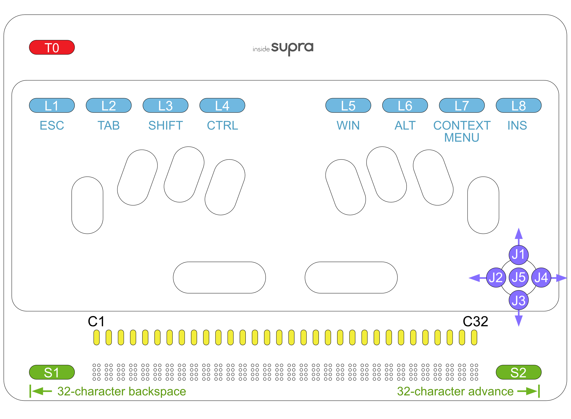

### Insertion and Removal of a Micro SD Card

Before using the tablet, you might wish to insert a Micro SD card to give yourself more storage space. To insert a card, hold it with the contacts facing down. Gently push it into the slot until it clicks into place. To remove the Micro SD card, push in on the card, and then release it. The card will pop out of its slot.

# Let’s use it

## Starting up and shutting down

### Turning on the insideSUPRA

To turn on the insideSUPRA, press the Power button located on the top right side of the tablet for a few seconds.

#### insideSUPRA boot-up options

The tablet boots up based on the default combination of the two available screen readers, JAWS and NVDA as well as the Home environment, an easy-to-navigate interface for a variety of blindness-focused applications.

Use the Control icon on Windows or Home Desktops to set startup preferences. Click on the Control icon to view three menu options: Stop, Launch and Settings. Stop is used to shut down, restart or hibernate insideSUPRA. Launch is used to choose screen reading software preference and/or Home application.

Validate Launch, and the selected programs will be launched instantly, and will be used the next time insideSUPRA is started.

You'll see the names of the 3 programs Home, JAWS and NVDA, followed in brackets by their startup status, yes or no.

To apply your choices, validate the Ok button, either using the routine cursors, or by pressing L2 (Tabulation), then key 8 or keys 9 and 0.

Only one screen reader can be enabled at a time.

JAWS is licensed software. The preinstalled starter version lasts 90 days. If you wish to use JAWS beyond the 90-day period, you will have to purchase a license or activate the product using a license you already have.

### Shutting down insideSUPRA Using the Windows Desktop

There are multiple ways to shut down the insideSUPRA. When on the Windows desktop, you can bring up the standard Windows shut down options from the start screen and select between restart, shutdown and hibernate, or by using Alt+F4 in the Windows desktop. Remember to save your work before shutting down insideSUPRA.

### Shutting down insideSUPRA Using the Control icon on Windows desktop

Control is a Home utility. Select Control and choose the Stop option. Then select Shutdown, Restart, or Hibernate.

If the insideSUPRA is unresponsive, press the Power button for 15 seconds to force quit all applications and shut down the insideSUPRA. To restart it, press the Power button again.

### Sleep Mode

To conserve battery and shorten the time it takes the insideSUPRA to boot up, you can put it in sleep mode. In this mode, resuming your work on the device is much faster than it is after completely shutting down.

Pressing the Power button briefly will put the insideSUPRA in sleep mode. Using Windows sleep mode is a good way to leave work up on your tablet if you know you are going to return to it in a relatively short period. A Windows device in sleep mode uses much less power than one which is fully operational. As the RAM is still receiving power, the operating system, along with any open documents or programs, are stored there. This significantly decreases the time needed for the insideSUPRA to start up.

If the battery becomes low, the RAM no longer receives power, and the tablet will boot up as if it were completely shut down previously instead of being put in sleep mode. To wake up the insideSUPRA, press and release the Power button. You will find yourself in the application open before putting the insideSUPRA in sleep mode.

### Hibernate

Choosing the hibernate option saves the current state of the RAM the hard disk and powers down the device.

To wake the insideSUPRA from hibernation, press and release the Power button. You will be returned to where you last left off.

When waking up the insideSUPRA, you will need to activate the Braille keyboard, even if it was activated during sleep mode.

Warning: If you plug insideSUPRA into the mains, a voice and Braille message will inform you that it is charging, but the tablet will remain in sleep mode.

## Interacting with the insideSUPRA

## Using the keyboards available with insideSUPRA

### The Braille Keyboard

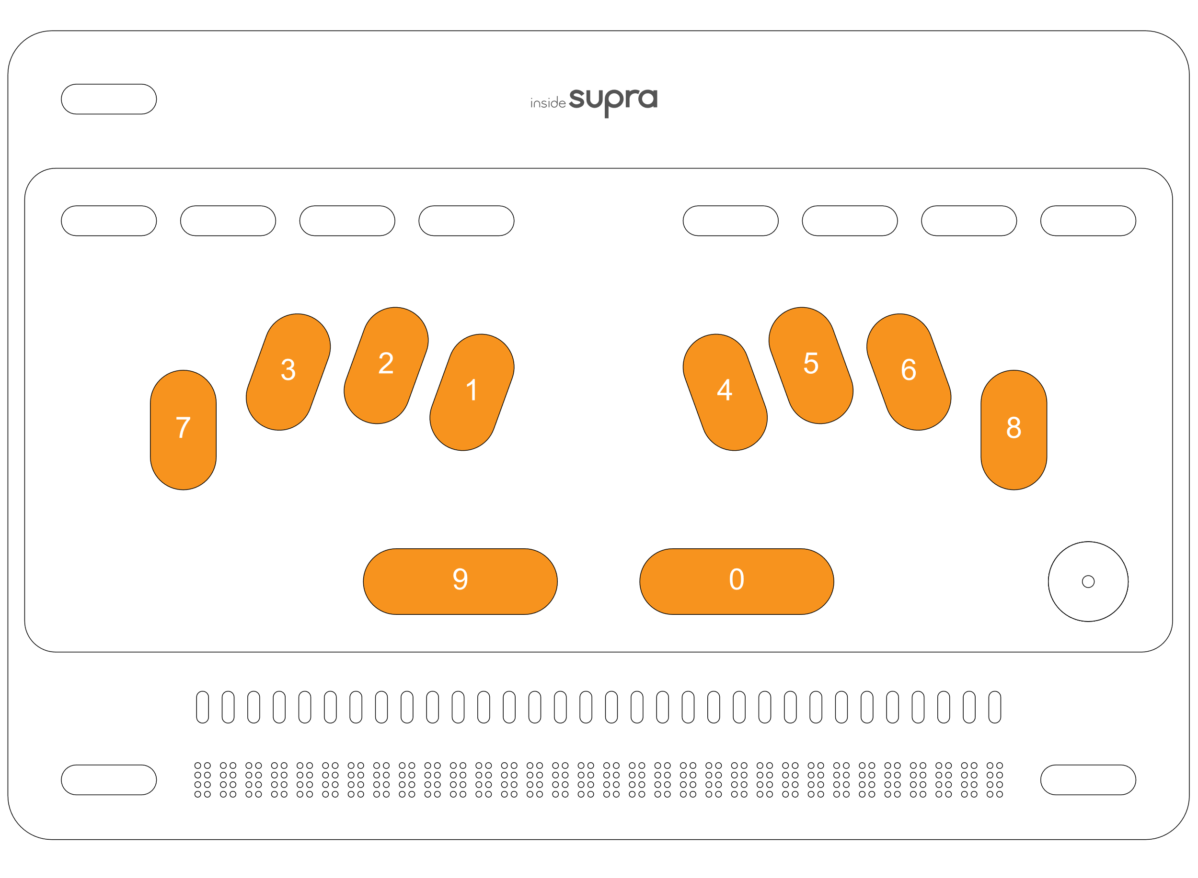You can use the braille keyboard to emulate the keys found on a standard Windows QWERTY keyboard. Please see the appendices at the end of this manual for key combinations corresponding to those keys.

The Braille input and output grade is chosen in the settings if using the Home environment, and in the options of your chosen screen reader everywhere else.

Tips:

To select the complete document, use the keyboard shortcut Ctrl+a

You can cancel your selection by pressing the Escape key named L1 on the shortcut keyboard.

If by mistake you have deleted some text, or if you wish to undo the last action, use the keyboard shortcut Ctrl+z.

To bold a selection, use the keyboard shortcut Ctrl+b.

To put a selection in italic, use the keyboard shortcut Ctrl+I.

To underline a selection, use the keyboard shortcut Ctrl+u.

To copy a selection, use the keyboard shortcut Ctrl+c.

To cut a selection, use the keyboard shortcut Ctrl+x.

To paste a selection, use the keyboard shortcut Ctrl+v.

You can use a mouse in Windows when the braille keyboard is activated and that an external screen is connected.

### Different functions for different zones



### The tables below show the various functions by zone

|  |  |  |
| --- | --- | --- |
| **ZONE T** | **ACTION** | **WINDOWS KEYBOARD SHORTCUTS** |
| **T0** | From Home, switches to the Windows desktop. From Windows, switch to Home | - |
| **T0 + L1** | Activates/deactivates the HID keyboard | - |
| **T0 + L2** | Back to the Home desktop | - |

|  |  |  |
| --- | --- | --- |
| **ZONE L** | **ACTION** | **WINDOWS KEYBOARD SHORTCUTS** |
| **L1** | Home – Menu: Exits menu and return to the application.  Home – Text: Deselects selected text.  NVDA: Escape. | **ESC** |
| **L2** | Home – Menu: Moves to the next object of a different type. Home – Text: Moves the cursor to the next word. NVDA: Tab. | **TAB** |
| **L3** | Shift (modifier) | **SHIFT +…** |
| **L3 + L3** | Caps Lock | **SHIFT** |
| **L4** | Control (modifier) | **CTRL +…** |
| **L4 + L4** | Home/NVDA/JAWS: Turn speech off | **CTRL** |
| **L5** | Windows (modifier) | **WIN+…** |
| **L5 + L5** | Windows | **WIN** |
| **L6** | Home: Opens Run menu. NVDA/JAWS: "Alt" key. | **ALT+…** |
| **L6 + L6** | ALT | **ALT** |
| **L7** | Home: Opens Pop menu. NVDA/JAWS: Context menu key. | **RIGHT CLICK** |
| **L8** | INSERT (modifier) | **INS+…** |
| **L8 + L8** | INSERT | **INS** |
|  |  |  |
| **L1 + L6** | Switches to another open Windows application (equivalent to Alt + Esc) if at least one Windows application is open. | **ALT ESC** |
| **L2 + L3** | Home - Menu: Goes to the previous object of a different type. Home - Text: Moves cursor to previous word.  NVDA: Shift +Tabulation. | **SHIFT TAB** |
| **L3 + J3** | Cursor-based vocalization | **CTRL+ RIGHT ARROW** |
| **L8 + L2** | Vocalization of the current object. | **INS+TAB** |

|  |  |  |
| --- | --- | --- |
| **ZONE S** | **ACTION** | **WINDOWS KEYBOARD SHORTCUTS** |
| **S1** | Moves the Braille display to the previous 32 characters. | **X** |
| **S2** | Moves the Braille display to the next 32 characters. | **X** |
| **S2 + C32** | Home - Menu: Moves to the last object on the same level. Home - Text: Moves cursor to end of paragraph. NVDA: End key. | **END** |
| **S1 + C1** | Home - Menu: Moves to the first object on the same level. Home - Text: Moves the cursor to the beginning of the paragraph. NVDA: "Home" key. | **HOME** |
| **S2 + C31** | Moves the cursor to the end of the document. | **CTRL END** |
| **S1 + C2** | Moves the cursor to the beginning of the document. | **CTRL HOME** |

|  |  |  |
| --- | --- | --- |
| **ZONE J** | **ACTION** | **WINDOWS KEYBOARD SHORTCUTS** |
| **J1** | Moves the cursor one line up, equivalent to "Up" arrow. | **UP ARROW** |
| **J3** | Moves the cursor one line down, equivalent to Down arrow. | **DOWN ARROW** |
| **J4** | Home – Menu: Goes to the next object of the same type. Home - text: Moves the cursor to the next character (right arrow). NVDA: Right arrow. | **RIGHT ARROW** |
| **J2** | Home - Menu: Goes to the previous object of the same type. Home - Text: Moves cursor to the previous character (left arrow). NVDA: Left arrow. | **LEFT ARROW** |
| **J5** | Home - Menu: Validates the selected object. NVDA: "Enter" button. | **ENTER** |

|  |  |  |
| --- | --- | --- |
| **ZONE C** | **ACTION** | **WINDOWS KEYBOARD SHORTCUTS** |
| **C1 - C32** | Equivalent to the routing cursor, validate the selected object, or move the cursor. | **SINGLE LEFT-CLICK** |
| **C1 - C32** | Quick double-press: Select the word. | **DOUBLE LEFT-CLICK** |

### Choosing Braille grades

Home, as well as NVDA and JAWS, have their own settings where you can choose a desired braille grade.

If you use computer grade 0, you must type in computer braille, and characters will be displayed with dot 7 for capital letters and dots 7 and/or 8 for accented and specific characters.

If you choose grade 1, you must type in literary braille. Characters will be displayed with capital and number signs.

### Choosing a braille grade in Home

In Home, you can choose between G0, G1 or G2, by going to the Settings/Braille menu.

Before changing the braille grade, close all open Home applications.

### Choosing a braille grade when NVDA is enabled

From the NVDA settings screen, choose the Braille category, and set the input and output table to your preferred grade.

### Choosing a braille grade with JAWS

In Windows, use JAWS commands to make your selection (Open parameters, check that the selected application is Default (all applications), then go to Braille / General/Output and Input).

### 

### The Braille HID (Human Interface Device) keyboard

This keyboard allows you to use the braille keyboard in Windows, even if no screen reader is active. The HID keyboard is activated using the button named T0+L1 key, a sound is associated with its activation, as well as a braille message (HID enabled for active and HID disabled for inactive). This keyboard gives access to Windows, as if an ordinary keyboard was connected to the tablet, even if no screen reader is active.

With this keyboard and shortcut Alt + Ctrl + n (1+0 then 1+4+0 then 1345) you can launch NVDA.

With this keyboard and shortcut Alt + Ctrl + j (1+0 then 1+4+0 then 245) you can launch Jaws.

See the combinations in the shortcut’s appendix.

Braille shortcuts

From the Braille keyboard you can input the function keys found on an ordinary keyboard, but also direct shortcuts, without going through a key sequence.

You now have the option of using modifier keys as a single key press or in combination with other keys. For example, to stop the voice message in progress, you must use the Ctrl key, in this case as a single keystroke with dots 2 5 0. On the other hand, to open a file, you must do Ctrl+o, in this case you will use the Ctrl keystroke to combine it with another key, in this case for Ctrl keystrokes 1 4 0, then for o keystrokes 1 3 5.

Modifiers are keys that can be used as a single press or combined with other keys, such as Ctrl, Alt, Insert, Windows and Shift,

Tip:

The 1+4+7+8+9+0 combination restarts the Core software that works jointly with the screen readers, keyboard and Braille display. Use only if you experience a loss of Braille display.

### What is the Alphanumeric Transcription Bar?

When you connect to an external screen, you will see at the bottom the Alphanumeric Transcription Bar. Anything written in braille is displayed cell-by-cell in black on the Alphanumeric Transcription Bar. This allows those who do not know braille to see what a braille user is typing.

When entering text using an 8-dot braille, every character is shown as entered on the Alphanumeric Transcription Bar. When using contracted braille, the characters shown on the Alphanumeric Transcription Bar may not always make sense to a sighted individual since some words can be written using just one cell while others use just a few cells. In braille, the word "just" is written using the letter J, which is made up of only three dots. The display will use simbraille to indicate the dots an insideSUPRA user has typed in cases where a word is made up of fewer letters than correspond to the number of print letters. Though some words may be shown on the Alphanumeric Transcription Bar in simbraille, the text will be displayed correctly in print on the screen.

## The Home environment

Home is a specially designed environment to host multiple blindness-focused applications. It utilizes a unique, structurally simplified Graphical User Interface (GUI) and a Braille user Interface (BUI) that arranges forms, objects, menu items, and dialog boxes along a horizontal line. This structure replaces a more complex tree-like scheme and eliminates the need to scroll up and down. The interface can be navigated using the left or right swipes.

## Objects

### What are objects?

Objects are the elements that make up the menus and dialog boxes you work with when using a computer. The name of the dialog box is the parent object, while any buttons in the box are child objects. The parent object is always the first part of any dialog box. To see the name of a dialog box currently on the screen, pan the display backward whit the key S1

### Parent-Child Objects

A parent object is written with a colon followed by two spaces because it is never the same type as the child objects following it. One space separates objects of the same type, while two spaces separate objects of a different type. If the name of an object is more than one word, the words are linked together by dot 8.

### Prefixes and Suffixes

In the Home environment, prefixes are used to show what type of objects are on the screen., d means directory, f means file, and u means unit, which is used when a thumb drive or SD card is inserted. Suffixes are used to show the state of an object, or that a chosen object is unavailable to insideSUPRA users. The state of an object will be indicated by using Yes or No. An object which is inaccessible to users of the insideSUPRA who are blind will have a G in brackets following the name of the object. The equals sign indicates an edit field.

## Moving focus and Braille reading

To move focus between objects of the same type, use the left and right arrows.

To focus on the next object of a different type, use Tab, L2 , or the Tab keyboard shortcut. To move the selection back to a different object type, tab back, L2+L3, or the tab back keyboard shortcut.

To validate an object, you can either use the joystick with the J5 key to validate the focused object, or use Enter on the Braille keyboard (either dot 8, or dots 9 and 0 together).

However, rather than using arrows or tabs to move the selection between different objects, if you're working in Braille, simply move your Braille reading using the S2 key. This does not change the object which is focused, but allows you to see all the objects displayed. Simply click on the object you want to validate, or in the edit field you want to modify. To click, use the Braille display to select the character or word, then move your finger above it in the cursor routines area and make 1 click.

If you move the focus with the arrows, the focused object will be displayed at the beginning of the Braille display. To validate, use the Enter key, or the routine cursors above the object. Focused objects are indicated by the presence of the cursor (dots 7 and 8) under the first letter of the object. For sighted persons, if you connect a screen, the object is highlighted in color, and on the alphanumeric transcription bar, the object is also highlighted in color, with the first white character on an orange background, indicating the presence of the cursor.

If you move your Braille reading, without moving the focused object, you'll need to use the routine cursors above the object to validate it by double-clicking. With this navigation, you won't necessarily see a focused object, either in Braille or for sighted people. If you wish to bring an object into focus, use 2 clicks.

If you want to bring Braille back to the focused object, use the L8-L2 keys (INS+TAB).

You can also use keyboard shortcuts.

When a menu is open, or in the Home screen, you can enter the first letter of the object to be used, this will validate the object. If two objects begin with the same letter, the focus will move between the objects beginning with the same letter, and you'll need to validate it. There are also direct keyboard shortcuts, for example to copy, paste or cut...

## Using the Note application within the Home Environment

### Moving Between Objects of a different Type

To move to and select the next object of a different type, use the Tab key (t+key 0 on the braille keyboard), or double click using the routing cursors. To move to and select the previous object of a different type, use Shift+Tab (t+key 9 on the braille keyboard,) or double click using the routing cursors.

To select an object, either use the joystick with key J5 tap or focus an object and press enter.

Panning display left or right does not change the selected object but allows the reading of other information on the display. In this case, to select an object, double-click in the routing cursors above the chosen object. To focus an object without selecting it, simply click with the routing cursors above the chosen object.

If you navigate with the arrow keys, the focused object will be displayed at the beginning of the braille display.

To select it, use the Enter key or a cursor routing key above the object. The focused object is indicated by the cursor (dots 7 and 8) under the first letter of the object. The object is highlighted in color on the connected screen and on the alpha-numeric transcription bar, with the first character in white on an orange background, indicating the cursor’s location.

If you move to another object without moving the focus, you must use the cursor routing keys above the desired object to select it. With this method, you won't necessarily see the focused object, neither in braille or in text, or simbraille for the sighted. You can also focus on an object by doing 2 clicks. If you wish to bring the braille back to the focused object, use keys L8-L2.

It is also possible to navigate among items by first letter.

When a menu is open or when you are in the first screen of Home, you can type the first letter of the object to be used; this will select. If two objects begin with the same letter, the focus will move between objects starting with the same letter and you will have to select it.

##### Navigation example moving the focus:

Home starts displaying the following: Apps, Explorer, Switch, Settings, and Control. The cursor is under the A of Apps.

To see the beginning of the line, click on key S1. You will read: Home, Apps, Explorer and Switch. Notice that there are two spaces between Home and Apps and one space between Apps, Explore and Switch. This indicates that Home and Apps are objects belonging to different groups and Apps, Explore and Switch belong to the same group. To move the focus from Apps to Home, use back tabulation, then to bring the focus back from Home to Apps, use Tabulation. Navigate between Apps, Explore, Switch, Settings and Control use arrow keys.

Tips:

To focus on the last object of the same type in a list, you can use keys S2+C32, and to go the first object of the same type in a list, use keys S1+C1.

#### The Run and Pop menu commands.

##### The Run menu

To launch the Run menu, use key L6+L6 quickly or use the braille keyboard shortcut Alt+R (a + key 0 followed by r).

The Run menu provides file management functions, such as New, Open, Import, Save, Save As, Print, Export, Mail etc. These menu options can vary depending on the application in use, but the menus themselves are generally set up in the same way.

The Run menu is generally made of different groups which are objects of different types. So, it is necessary to use Tabulation or back Tabulation to move from one group to another.

Inside the same group, objects are of the same type. Use the arrow keys to navigate between the objects.

If you're navigating in Braille, the Braille display will move 32 characters backwards, until it shows you the name of the group you're in, then it will move 32 characters backwards to show the previous objects.

##### The Pop menu

To start the Pop menu, you can use key L7 or the context menu Braille keyboard shortcut (m+key 9+key0). The Pop menu is a context menu which means that it can change depending on where it is opened.

## Home menu items

Apps is a collection of applications specifically designed to simplify user interaction with the insideSUPRA to perform operations such as notetaking, file management, printing, emailing and other.

Explorer, is a file manager to explore the content of the insideSUPRA.

Settings is the software utility enabling a user to choose program parameters.

Control is a program that enables a user to choose braille grades, screen readers and manage power options including insideSUPRA’s shutdown.

Tip:

* When you are in an application, at any time you can come back to the welcome Home menu using the keyboard shortcut h+9+0 or use keys T0+L2.

## Explorer.

Explorer is an application used within other apps. In Note for example if you open a file, you will use Explorer. Explorer is a file manager allowing to create folders and files, to rename or delete them, and to copy and paste them. You can open several Explorers at the same time, and switch between them.

### Example:

Explorer is the parent element.

It consists of 3 groups of different types, called Path, Content and Properties.

The Path group shows the place you are exploring. You will find a unit and folder tree structure. By selecting a unit or a folder in Path, its content will be automatically displayed. The cursor is automatically on the first object of the list in the Content group,

Prefixes are used to show the nature of the objects.

u. is for unit such as physical drives (hard disk, SD card, USB stick).

d. is for directory.

f. is for file.

The Content group displays selected content’s location in the Path group. When you open Explorer, you find yourself in this group by default. When Explorer is started, Content displays Home folder and then current drives, u.C by default (which corresponds to the insideSUPRA hard drive). If a USB stick is connected, it will be displayed in a row. Files created in Home applications will be saved in the Home folder by default. Each Home application will have its own folder in Home.

The Properties group displays the properties of a selected object in the Content group. File properties include its name, order in a list of files, date of creation, size, and location. They are sorted alphabetically by default.

### Navigation:

The three groups are of different types, to move the focus from one to another, use tabulations. To move within a group, use the arrows. If you open a unit, a file or a folder, this will put the focus on its Content. If you select a .not file, it will open it in the Note application. If you select another type of file, nothing will happen.

Tip: You can enter the first letter of the folder name or the file you wish to reach, the focus will be on the first object beginning with the letter entered; by entering the same letter again you will go to the next object beginning with the same letter.

Tips:

* To exit a file and get back to the parent folder, use dot 7 on the Braille keyboard. The other way is to go to Path and select the object you wish to go through.
* To go to the end of a list, use the End command, which is keys S2+C32, or Braille dots 4-5-6+key 9+key 0. To go to the beginning of a list, use the Origin command with keys S1+C1 or with Braille l+key 9+key 0.
* When browsing in braille to get back to the focused object, use the keys L8+L2.
* When browsing in braille to focus an object, use the routing cursors with 2 clicks above the object.

### The Run menu in Explorer

To open the Run menu, use the key L6+L6 quickly, or perform the Alt+r shortcut with the braille keyboard.

If Explorer or Path are focused, the Run menu only contains the "Quit Explorer" command.

If Content or Properties is focused, you can access other commands.

Whether you open the Run menu from Content or from Properties, the command will act on the focused object in the Content group.

The Run menu gives you the possibility to create a new file for the Note app whose extension is .not, to create a new folder and to exit Explorer.

### The Pop menu in Explorer

The context menu operates on the focused element and gives you the possibility to Copy, Cut, Delete or Rename the focused object.

If you copy or paste a focused object, you will be able to paste it to another destination by calling the Pop menu. After using Copy or Cut, when opening the Pop menu, the first choice will be Paste.

To delete an object, you need to focus it either with the arrows or through the cursor routings, doing a double click. Then open the Pop menu and select Delete. There will be a message asking to confirm the deletion. Select Ok if you do want to delete the file, if no, select Cancel to abandon the deletion of the focused object.

To rename an object, you need to focus it either with the arrows or through the cursor routings, doing a double click. Then open the Pop menu and select Rename. You will find yourself in an edit field with the current name selected. You can modify it then select Ok, or cancel if you no longer wish to rename the file.

Tips:

* To copy use the keyboard shortcut Ctrl+c
* To cut use the keyboard shortcut Ctrl+x
* To paste use the keyboard shortcut Ctrl+v
* To delete use the Del command (d+key 9+key 0)
* To rename use the F2 command

## Note.

Note is a text editor to create and save documents in the .not format.

Note lets you import and export files in txt, rtf, odt, doc, docx, pdf, ng0, ng1, ng2 formats.

The text can be enhanced with bold, italic and underline attributes (files in contracted braille excepted). It is possible to select some text to delete, copy or cut it, then paste it.

Depending on the setup configuration in Settings, you will be able to type in several braille grades. Note that a .not file is saved in the braille grade which has been set up when creating the file, and it will always be open in the same grade. It won't depend on the Settings configuration when you reopen it.

You will find the Note application in the Apps group of the Home first screen. Select Apps then Note to open the application.

When opening Note, you find yourself in the Run menu which allows you to create a new document, open an existing document or import a document.

You can also open several files at the same time and switch between them if you open several instances of the Note application.

If you open Note one time only, you will be able to work in one file at a time only.

Information:

When you move your Braille reading in a document with the S1 or S2 keys, you are not moving the cursor, only your view of the document. The cursor remains where you started. If you want to write where you arrived, you'll need to call up the cursor using the cursor routines. If you type text without calling up the cursor, the Braille display will return to the cursor position and the character will have been inserted there.

When saving the file, the location of the cursor is memorized, so that the next time you open the file, you will be directly positioned at this place.

### The Run menu from Note

To open the Run menu, press L6+L6 quickly, or use the Alt+r keyboard shortcut (Alt 1 0 then r 1 2 3 5).

Run is the parent element:

It has 3 groups of different types, named Begin, Save and Actions.

When launching Note, you will find yourself in the Begin group.

#### The Begin group

The Begin group includes the following options: New, Open and Import.

New opens a new document in .not format. A temporary name is given to the new file. For example, the temporary name can be Note_2019-09-24.not. It starts with Note_ and is followed by the current date starting with the year followed by the month and day. You will find this temporary name when saving or exporting the file.

Open allows you to open a file saved in .not format.  
By choosing Open, you will find the same layout than in Explorer with the Path, Content and Properties groups. You just need to select a file to open it.

Import lets you open and convert in .not file from the .doc, .docx, .odt, .pdf, .rtf, .txt, ng0, ng1, ng2. formats.  
Ng0, ng1 and ng2 formats are the formats previously used in the Home version 1.  
When you select Import, you are prompted to choose the file format that you are looking for. You have the choice between .doc, .docx, .odt, .pdf, .rtf, .txt, ng0, ng1, ng2 or All.  
Depending on the selected file format, you will find yourself in the layout used by Explorer with Path, Content and Properties groups. You just need to select one file to open it. Only the files in the selected format will be displayed.

#### The Save group

The Save group lets you choose between Save, Save as, Export.

You won't find the Save option when you are in a new file.

You can use Save when a file has been already named and saved once.

Save allows to save the modifications made in the file at any given time. Once Save is chosen, you will be placed back inside the document. Remember to save your work on a regular basis in order to avoid any data loss. The keyboard shortcut Ctrl+s is assigned to this function.

Save as works for a new document or for an already named document. Save as allows to assign a new name to the document.  
When you select Save as, you will find the layout used in Explorer, namely the Path, Content and Properties groups. You will find yourself in the Content group, on the temporary file name if it is a new file, or on the name of the document if it is an already named document. If you change the folder, the file name will still be displayed. Select the temporary document or the name of your existing file, then rename the file and select the Ok button.

Export is different from Save as, because it doesn't save your file, but it creates a copy in the required format at any given moment.

When you select Export, you will be asked to choose the output file format. You can choose between the .doc, .docx, .odt, .pdf, .rtf, and .txt. formats.  
Depending on the chosen format, you will arrive in the Explorer layout, namely the Path, Content and Properties groups. You will be in the Content group, on the temporary name if it is a new file, or on the name of the document if it has been already named. If you change the folder, the file name will still be displayed. Select the temporary document or the name of your existing file, then rename the file and select the Ok button. You will be back in your document. Remember to save your document.

#### The Actions group

The Actions group includes Mail, Print, Statistics and Quit Note.

Mail switches to your default Windows email client. The content of the document is pasted in the e-mail body.

If using this feature for the first time, you will need to configure your email client if you’ve not previously done so.

Print, prints your document in black on the selected printer in Windows. If no printer is installed yet, you will get an error message. It won't be possible to use the virtual "Microsoft Print to PDF" printer to get a pdf document. You will have to use the export function in the Save group.

Statistics, shows the braille grade currently in use in the document, how many words and paragraphs are present in the document.

Quit Note, allows you to exit the Note application. After choosing Quit Note, you are asked if you wish to save the ongoing file.  
If you answer Yes and it is a new document, the Save as menu from the Save group will be displayed in Note. If you answer Yes and that the document has already been named, then the modifications made to your document will be automatically saved, the file will be closed and you are brought back to the Home welcome menu.  
If you click on No for a new document, it will be lost and the app closes. For an already named document, the modifications made since the file has been opened will be lost.

Clicking on Cancel will bring you back into the document.

Tips:

* When you open the Run menu with the keyboard shortcut, you will be in a group. The first letter of the command is used as a shortcut letter. If your command is in the previous group, use the back-Tab command then the shortcut letter of the command you wish to execute. For example, if you are in a document and that you want to exit Note, you need to use the Quit Note command which is in the Actions group. When you open the Run menu with Alt+r you find yourself in the Save menu. To go to the Actions group, use the Tab command then letter q to execute the Quit Note.
* To get back to the first screen in Home, use the keys T0+L2, or Home command (1 2 5 9 0).

#### The Pop menu of Note

To open the Pop menu, use the L7 key, or the Context menu keyboard shortcut (on the keyboard the letter M with 9 0 (1 3 4 9 0)).

This context menu acts on the selected text.

You will find Copy, Cut, Paste, Font and Select.

If you copy or cut selected text, you will be able to paste it into another destination by calling the Pop menu.

Font lets you choose to bold, put in italic or underline the selected text (not working with contracted braille).

Selection gives the following choices: Beginning, End, Cancel and All. The selected text is displayed with dots 7 and 8 under the selected characters.

Beginning begins the selection where the cursor is and brings you back in the text. To mark the end of the selection, you can either move the cursor with the arrows, or word by word with the L2 key, or move then click after the last character of the end of the selection. Then you can apply the required action on the selection, such as delete, copy or bold it.  
End is a step marking the end of selection where the cursor is. Any movement of the cursor will remove the selection.

Cancel removes the selection that you have started. Escape does the same thing.

All selects the entire document and puts the cursor at the end of the document.

Tips:

* You can select a word with a double click above the word.
* You can extend your selection word by word with the L2 key to the right, or the L3+L2 keys to the left.
* To select the complete document, use the keyboard shortcut Ctrl+a (CTRL 1 4 0 then a 1).
* You can cancel your selection with the Escape key,or pressing escape on the keyboard (1 5 0).
* If by mistake you have deleted some text, or if you wish to undo the last action, use the keyboard shortcut Ctrl+z (1 4 0 then z (1 3 5 6 ).
* To bold a selection, use the keyboard shortcut Ctrl+b.
* To put a selection in italic, use the keyboard shortcut Ctrl+I.
* To underline a selection, use the keyboard shortcut Ctrl+u.
* To copy a selection, use the keyboard shortcut Ctrl+c.
* To cut a selection, use the keyboard shortcut Ctrl+x.
* To paste a selection, use the keyboard shortcut Ctrl+v.

## Calculator.

Calculator allows you to make calculations with the 4 operators, as well as for finding square roots, exponents, inverses, changes of sign, percentages, and using memory functions.

Information:

* Calculator is using 8-dot Computer braille, even if another braille grade has been selected in "Settings.
* You can open multiple calculators at the same time.

Calculator comprises a parent object and of 2 groups. The first one is called "Operations" and the second "Result".

When you open Calculator, you find yourself in the Operation group and the input cursor is blinking. The Result group displays =Result(g) which means that the result is greyed out. It is not accessible for the user.

The parent object displays "Apps calculator" which is the name of the application. By selecting this object, you will exit the application without using the Run menu.

To move the focus between the parent element and between the groups, use the key L2, or press Tab with the braille keyboard (dots 23450).

The Operation group is an edit field.

The Result group is not editable, it is only used to view the result.

#### Use

#### Operations

You must enter the operations in the "Operation" group

Calculator is using 8-dot Computer braille, you must then enter the numbers without the braille prefix. To enter 1, press dots 1 and 6, for 2, press dots 1 2 6 and so on.

It is an editing field. You can move the cursor with the arrows or the cursor routings, modify text, select, copy, cut and delete it.

#### Input rules:

1/ The exponent can only be used on the first term of an expression.

2/ As a first term, it is not possible to enter a negative number. To enter a negative number as a first term, you will have to type it in positive, then use the F9 change sign function (dots 2 4 9).

3/ To enter a square root, first type the number then square root. It will the same for inverse and change sign.

4/ Only dot (dots 4 6) is set as a separator. Comma is not accepted.

5/ Only numbers, operators and functions can be entered. If you enter another character, you will hear an error sound and there will not be any modifications on the braille display.

#### Calculation sequences:

It is impossible to have more than 2 terms in an operation.

If you want to calculate 12+23+34, enter 12+23 first, and then you enter the plus sign, the result of the calculation will be displayed in order to chain the calculation, you will then read 35+Enter 34.

It is not a scientific calculator. There is therefore no analysis of calculation priority rules.

For long calculations it will be necessary to decompose it. For example, to calculate 25+12/4, first it will be necessary to calculate 12/4, then add 35. Otherwise, if the expression were entered as is, the calculation would be 35+12 and divide the result by 4.

#### Result

After entering an operation, the calculation must be launched to see the result.

* Enter the equal sign (dots 1 2 3 4 5 6).
* Enter dot 8 or dots 9 and 0 at the same time.
* Press the key L2.

Whatever method you use, you will find yourself in the Result group where you will read = and the result.

If you don't see the result, it means there is a syntax error. For example, if you have entered only one term, or if you have copied from Note a calculation with more than two terms in the operation.

You cannot neither edit nor modify the result.

However, it is reusable. If you enter an operator at first, you will switch to the "Operation" group, where the result will have been incorporated, followed by the entered operator.

When you enter a new operation or when you modify the terms of a calculated operation, the result is not displayed.

#### Reset

Whether you are in the "Operation" or "Result" group, it is possible to use the C (Clear) function which deletes the entire entered calculation. To do this, type the F2 shortcut (dots 1 2 9) or use the POP menu.

#### Percentage calculation

##### Adding or subtracting percentages

To add 25% to 150, you must enter 150+25%

To insert the percentage, you can either use the F4 function (dots 1 4 5 9), or the % sign (dots 1 4 6).

When the percentage sign is inserted, the value of 25% of 150% is displayed. You will read 150+37.5.

To see the result of the calculation, type the equal sign or do Enter, or press the key L2

You will read =187,5.

To subtract a percentage, proceed the same way.

#### Calculating the value of a percentage

To calculate 25% of 150, you must type 150*25%

To insert the percentage, you can either use the F4 function (dots 1 4 5 9), or the % sign (dots 1 4 6).

When the percentage sign is inserted, the 25% value is displayed (0.25). You will read 150*0,25

To see the result of the calculation, enter equal or press Enter, or use the key L2.

You will read =37.5.

#### The RUN menu of Calculator

To open the Run menu, you can use quickly the key L6+L6, or you can use the keyboard shortcut Alt+r (type the letter a and 0 at the same time, then type r, dots 1 2 3 5).

The Run menu includes only the function "Quit calculator".

Otherwise, to exit calculator, you can also use the Alt+F4 keyboard shortcut. Type the letter a for Alt (dot 1) and 0 at the same time, then F4 (dots 1459).

#### The POP menu of Calculator

To open the Pop menu, use key L7, or use the context menu keyboard shortcut (the letter m with 9 and 0, so 1 3 4 9 0)

The context menu acts on the focused item or on the selected text.

#### The POP menu of the "Operation" group

In the Pop menu you will find Operators, Modificators, Punctuation, Memory, Mathematical functions, copy, cut, paste and select.

Select «Operators », you will find:

* Plus, or in braille dots 3 4 6
* Minus, or in braille dots 3 6
* Multiply, or in braille dots 1 6
* Divide, or in braille dots 3 4
* Equal, or in braille dots 1 2 3 4 5 6, or Enter with dot 8 or dots 9 and 0, or the key L2.
* Cancel

Select « Modificators », you will find:

* Delete, or in braille Backspace (dot 7)
* C, to clear the entire operation in Operation group, or F2 using functions (dots 1 2 9).
* CE, to clear the most recent number or sign, or F3 using functions (dots 1 4 9).
* Cancel

Select « Punctuation », you will find:

* , or dot 2 in braille.
* Cancel

Select « Memory », you will find:

* Mc (Memory clear) sets the memory to 0 or keyboard shortcut Ctrl+l. For control, type the letter c (dots 1 4) and 0 at the same time, then the letter l (dots 1 2 3).
* Mr (Memory recall) inserts the memory content or keyboard shortcut Ctrl+r. For control, type the letter c (dots 1 4) and 0 at the same time, then the letter r (dots 1 2 3 5).
* M+ (Memory Add) adds the value on the display to the memory content, or keyboard shortcut Ctrl+p. For control, type the letter c (dots 1 4) and 0 at the same time, then the letter p (dots 1 2 3 4).
* M- (Memory Subtract) subtracts the value on the display to the memory content, or keyboard shortcut Ctrl+q (dots 1 2 3 4 5). For control type the letter c (dots 1 4) and 0 at the same time, then the letter q (dots 1 2 3 4 5).
* Ms (Memory store) puts the number on the display into the memory or keyboard shortcut Control + m. For control type the letter c (dots 1 4) and 0 at the same time, then the letter m (dots 1 3 4).
* Cancel
* Memory clear (MC); Ctrl l 1 4 0 then 1 2 3;
* Memory recall (MR); Ctrl r 1 4 0 then 1 2 3 5;
* Memory Add adds the number on the display to the memory (M+); Ctrl p 1 4 0 then 1 2 3 4;
* Memory Subtract subtracts the number to or from the memory (M-); Ctrl q 1 4 0 then 1 2 3 4 5;

Memory Store puts the number on the display into the memory (MS); Ctrl m 1 4 0 then 1 3 4;

Select « Mathematical functions », you will find:

* Percentage or dots 1 4 6, or F4 function (dots 1 4 5 9)
* Square root or dots 3 4 5, or F5 function (dots 1 5 9).
* Inverse or dots 1 2 3 5, or F6 function (dots 1 2 4 9).
* Exponent (power), or F7 function (dots 1 2 4 5 9).
* Opposite sign or F9 function (dots 2 4 9).

To copy or use keyboard shortcut Ctrl+c. For control type the letter c (dots 1 4) and 0 at the same time, then the letter c (dots 1 4).

To cut or use keyboard shortcut Ctrl+x. For control type the letter c (dots 1 4) and 0 at the same time, then the letter x (dots 1 3 4 6).

To paste or using keyboard shortcut Ctrl+v. For control type the letter c (dots 1 4) and 0 at the same time, then the letter v(dots 1 2 3 6).

Select « Select », you will find:

* Start or F8 keyboard shortcut (dots 1 2 5 9), after selecting start, you come back to the operation being entered, move the cursor with the arrows or the routing cursors, and use the command you want to.
* End
* All or Ctrl+a keyboard shortcut, type the letter c dots 1 4 and 0 at the same time, then the letter a dot 1). After "All" is selected, you come back to the operation being entered with the entire expression now selected. Then you can use the command you want to.

#### The POP menu of the "Result" group

In the Pop menu of "Result" you will fin Copy the result, Memory clear, Memory add, Memory subtract and Memory store. It is also possible to use keyboard shortcuts seen above.

### Summary of functions and keyboard shortcuts

The list below presents the different available functions and keyboard shortcuts available. Columns are separated by a semi-colon (;).

Some of the functions have 2 keyboard shortcuts.

Functions; Keyboard shortcuts and corresponding dots, other shortcuts

Alt key; 1 0;

Control key; 1 4 0;

Shift key (capital letters); 2 3 4 0;

Escape key; 1 5 0;

Tab key; 2 3 4 5 0;

Back tab key; 2 3 4 5 9;

C key, clears the entire operation; F2 1 2 9;

CE key, clears the most recent operand; F3 1 4 9;

Delete a character; BackSpace 7;

The plus sign +; 3 4 6

The minus sign -; 3 6;

The multiplication sign x; 1 6

The division sign ÷; 3 4;

The equal sign (Result) =; 1 2 3 4 5 6

The comma ,; 2;

The dot .

Memory clear (MC); Ctrl l 1 4 0 then 1 2 3;

Memory recall (MR); Ctrl r 1 4 0 then 1 2 3 5;

Memory Add adds the number on the display to the memory (M+); Ctrl p 1 4 0 then 1 2 3 4;

Memory Subtract subtracts the number to or from the memory (M-); Ctrl q 1 4 0 then 1 2 3 4 5;

Memory Store puts the number on the display into the memory (MS); Ctrl m 1 4 0 then 1 3 4;

Percentage; F4; 3 4 6

Square root; F5; 3 4 5

Inverse (or fraction); F6 1 2 4 9; 1 2 3 5

Exponent or Power; F7 1 2 4 5 9; 4

Opposite signs; F9 2 4 9;

Run menu; Alt r 1 0 then 1 2 3 5;

Pop context menu; 1 3 4 9 0;

## Switch.

Switch shows the currently open applications.

Home is a multi-task application. It allows opening several apps at the same time, as well as several instances of the same app.

Switch is in fact a Run menu.

You will always see Home in the first position, which allows you to get back to the welcome menu of Home. Home is followed by the name of the currently open applications, and if the application is open several times, a number in brackets shows how many times this app is open.

To get back to an open application, just select it.

To get back to an app which has been open several times, you need to select it. This will open the list of the different files, numbered 1/x. If they are Explorer apps, you will see the path it uses. If it is a Note file, you will see the sequence number and the file name.

To exit Switch, you can use the Escape command, or click on the parent element, or use the command to get back to the welcome menu.

## Settings.

Settings shows the different available settings and information concerning Home.

It offers options for Braille, Sounds, Voice, Print, About, Battery, Date and Time.

It is in fact a Pop menu. To exit this Pop menu, use the escape function, or select the Pop parent object, or go to the first screen of Home.

Settings show the current options for braille grade, sounds and voices.

Braille displays in brackets the grade currently used. If you select braille, the list of the different braille grades available will be displayed. You can choose between Grade 0 grade 1 and grade 2. Following each braille grade, you will see in brackets its state indicating if it is currently in use (yes) or not (no).  
The selected grade will be used to write in Note and to display the menus. Before changing the braille grade, you must close all open applications.

Sound allows you to turn on or off the sounds that you hear when you make some gestures.

Voice lets you choose to turn on or off the text-to-speech. The current state is displayed to you and to change it, you just need to select this object.

Print gives the information on the selected printer by default in Windows. As a reminder, if "Microsoft Print to Pdf" is selected, you won't be able to use it to generate a pdf file from Note. You will have to use the Export function from the Save group.

About shows the Home version.

Battery shows the percentage of battery remaining, as well as if the power supply is connected or not. A Battery low message is displayed when there is only 5% of power remaining, and from 2%, the message is constantly displayed. You must then connect your device to charge it. The message will disappear when 2% of charge is exceeded.

Date and Time lets you know date or time provided by Windows. If the information is wrong, it is necessary to adjust values in Windows.

## Control

Control lets you choose how you wish to start or shut down the insideSUPRA. The menu shows Stop and Launch.

Stop lets you choose between Shutdown, Restart and Hibernate. For more information on the different sleep modes, see chapter 4.3.

Launch lets you choose the startup configuration of the insideSUPRA.

Several start up configurations are possible such as:

* Home only
* NVDA only
* JAWS only
* Home and NVDA
* Home and JAWS

Select Launch, the selected programs will start immediately and will be launched automatically the next time the insideSUPRA starts.

You will see the name of the 3 programs, Home, JAWS and NVDA followed in brackets by their start up state, yes or no.

To apply your choices, select the OK button, either with the cursor routings, or by using the key L2, then with 1 click with the routing cursors.

It is not possible to activate JAWS and NVDA at the same time. If one of them is already active, the activation of the other will automatically deactivate the first one.

### insideSUPRA boot up process options

The tablet starts depending on the startup chosen configuration.

In order to choose the right startup configuration, you need to use the Control menu available either in Windows by clicking on the Control icon on the desktop, or in Home in the Control menu available in the main Home menu.

Control is a Home utility. If Home has not been started, 5 seconds are necessary for Home to be loaded.

By selecting Control, you will arrive in a menu which uses the Home navigation.

At the opening of Control, you will have the choice between Stop and Launch.

# Windows

With insideSUPRA you can use either NVDA or JAWS as a screen reader.

## NVDA

InsideSUPRA is using the NVDA screen reader (Non Visual Desktop Access) to give you access to Windows and its numerous applications.

You must use the standard Windows and NVDA commands the insideSUPRA keyboard. The choice of the input/output braille table is managed by NVDA, as well as for the reading voice using the NVDA Options menu.

## JAWS

JAWS is installed and set up on the insideSUPRA. InsideSUPRA is compatible with JAWS version 2018 and above. If you have a license, you can activate JAWS. Otherwise, JAWS will run in demo mode.

JAWS manages the choice of the input/output braille table, as well as the reading voice through its options menu.

### Special Desktop Icons

Three icons have been added to the Windows desktop to make accessing certain commonly used options a more rapid and intuitive process. Found on the first row of desktop icons, from left to right they are: Control, Applications, and Administrator.

#### Control

Control lets you choose how you wish to start or shut down the insideSUPRA. The menu shows Stop, Launch and Settings.

#### Stop

Stop lets you choose between Shutdown, Restart and Hibernate. For more information on the different sleep modes, see Let's use it chapter.

#### Launch

Launch lets you choose the startup configuration of the insideSUPRA, such as:

Home only

NVDA only

JAWS only

Home and NVDA

Home and JAWS

Select Launch, the selected programs will start immediately and will be launched automatically the next time the insideSUPRA starts.

You will see the name of the 3 programs, Home, JAWS and NVDA followed in brackets by their start up state, yes or no.

To apply your choices, select the OK button, either with the cursor routings, or by using the key L2, then with 1 click with the routing cursors.

It is not possible to activate JAWS and NVDA at the same time. If one of them is already active, the activation of the other will automatically deactivate the first one.

insideSUPRA boot up process options.

The tablet starts depending on the startup chosen configuration.

In order to choose the right startup configuration, you need to use the Control menu available in Windows by clicking on the Control icon on the desktop.

At the opening of Control, you will have the choice between Stop, Launch and Settings (see the above explanation).

With insideSUPRA you can use either NVDA or JAWS as a screen reader.

NVDA

InsideSUPRA is using the NVDA screen reader (Non Visual Desktop Access) to give you access to Windows and its numerous applications.

You must use the standard Windows and NVDA commands and the insideSUPRA keyboard. The choice of the input/output braille table is managed by NVDA, as well as for the reading voice using the NVDA Options menu.

JAWS

JAWS is installed and set up on the insideSUPRA. InsideSUPRA is compatible with JAWS version 2018 and above. If you have a license, you can activate JAWS. Otherwise, JAWS will run in demo mode.

JAWS manages the choice of the input/output braille table, as well as the reading voice through its options menu.

##### Settings.

Settings shows the different available settings and information concerning the insideSUPRA settings.

It offers options for Sounds and About.

Sound allows you to turn on or off the sounds that you hear when you make some gestures.

##### About

About shows the version. Select OK to exit.

#### Applications

Selecting the Applications icon shows you a list of almost all applications installed on the tablet. The applications are displayed in a list using rows and columns.

#### Administrator

When Administrator is selected, Windows 11 File Explorer is loaded. You find yourself in the default user section.

#### User guide

In this folder you'll find all the documents you need to get started with your device, as well as the file containing your serial number.

## Technical Support and Troubleshooting Your Tablet Remotely

Should you experience any issues with the insideSUPRA, or need to send it in for repair, please contact your local distributor.

### Password of the insidevision session

The default password is: admin

You will need it if you come to the Windows screen log. Activate the braille keyboard to enter it.

### Remote Assistance

It is possible to have someone control the insideSUPRA remotely in order to troubleshoot or offer technical support. Anyone who has remote access to the insideSUPRA can view the contents of your hard drive and modify settings. A person controlling the insideSUPRA from a remote location interacts with the tablet using a keyboard and mouse. Insidevision is not responsible for any loss of data or damage to the tablet which may occur when a third party has been given permission to access the unit in this manner.

You will need to provide the individual providing assistance with the tablet’s ID number and password. The insideSUPRA should be connected to the Internet using a high-speed connection with the TeamViewer application running.

Once you have found TeamViewer on the desktop, launch it by pressing dot 8 with the braille keyboard active. Once the application loads, press tab three times. You may do this by pressing dots 2, 3, 4, 5, and 0 on the braille keyboard. Tabbing three times will allow you to read and make note of the tablet’s unique nine-digit ID number. The ID number and password change each time a new TeamViewer session is launched.

## Care and Maintenance of insideSUPRA

Before cleaning the insideSUPRA, shut it down, and unplug the USB C cable if the device is charging, as well as any accessories or peripherals. Clean the entire tablet using a soft, dry, lint-free cloth such as those used for cleaning eyeglasses and electronics. Using rough-feeling material to clean the aluminum case will cause scratches.

Do not use paper towels, bath towels, hand towels, or any other rough-feeling material when cleaning the insideSUPRA. Do not use compressed air, aerosol sprays, window cleaner, or any other chemicals when cleaning any part of the tablet.

Do not allow moisture to get into any of the insideSUPRA’s ports. Also, do not allow liquids to come into contact with the insideSUPRA. Damage caused by moisture or liquid is not covered under the manufacturer’s warranty. If the tablet comes into contact with moisture or liquid, please contact your local distributor as soon as possible.

## Appendix F: NVDA shortcuts

|  |  |
| --- | --- |
| Key modifier in conjunction with other keys | Dot Combinations |
| Press and hold Alt then release | 1+0 |
| Press and hold Ctrl then release | 1+4+0 |
| Press and hold Insert then release | 2+4+9+0 |
| Press and hold NVDA key then release | 1+3+4+5+0 |
| Press and hold Shift then release | 2+3+4+0 |
| Press and hold Windows then release | 2+4+5+6+0 |
| Cancels pending modifiers | 1+2+3+5+7+8+9+0 |
| Single-pressed keyboard keys |  |
| Keyboard shortcuts | Dot Combinations |
| Escape | 1+5+0 |
| F1 | 1+9 |
| F2 | 1+2+9 |
| F3 | 1+4+9 |
| F4 | 1+4+5+9 |
| F5 | 1+5+9 |
| F6 | 1+2+4+9 |
| F7 | 1+2+4+5+9 |
| F8 | 1+2+5+9 |
| F9 | 2+4+9 |
| F10 | 2+4+5+9 |
| F11 | 1+3+9 |
| F12 | 1+2+3+9 |
| Print screen | 1+2+3+4+9+0 |
| Pause | 1+2+3+4+9 |
| Tab | 2+3+4+5+0 |
| Shift+Tab | 2+3+4+5+9 |
| Caps lock toggle | 7+9 |
| Shift | 3+7+5+0 |
| Ctrl | 2+5+0 |
| Windows | 3+5+6+8+0 |
| Alt | 2+0 |
| Space | 0 ou 9 |
| Median point (dot 8 alone) | 8+0 |
| No breaking space (dot 7 alone) | 7+0 |
| Right click (contextual menu) | 1+3+4+0 |
| Enter | 8 ou 9+0 |
| Backspace | 7 |
| Inser. | 3+5+9+0 |
| Delete. | 1+4+5+9+0 |
| Home | 1+2+3+9+0 |
| End | 4+5+6+9+0 |
| Previous page | 1+3+9+0 |
| Next page | 4+6+9+0 |
| Down arrow | 4+9+0 |
| Left arrow | 3+9+0 |
| Right arrow | 6+9+0 |
| Up arrow | 1+9+0 |
| Num lock toggle | 8+9 |
| Volume up | 1+2+3+6+0 |
| Volume down | 1+2+3+6+9 |
| Mute volume toggle | 1+2+3+6+8+0 |

## Direct shortcuts

|  |  |  |
| --- | --- | --- |
| Shortcut | Action | Dot Combination |
| Alt+f4 | Closes an application | 1+2+3+4+5+9+0 |
| Windows + a | Opens Windows notification area | 2+5+9+0 |
| Windows + e | Opens file explorer | 1+5+9+0 |
| Windows + m | Windows desktop | 1+3+4+9+0 |
| Windows + r | Opens run command box | 1+2+3+5+9+0 |
| Windows + ; | Opens emojis tool bar | 2+3+9+0 |
| Windows + + | Enlarges Windows zoom | 1+3+5+6+0 |
| Ctrl Right arrow | Moves the cursor to the next word | 5+9+0 |
| Ctrl Left arrow | Moves the cursor to the previous word | 2+9+0 |
| Ctrl + alt + tab | Opens the list of open applications. | 1+2+3+4+5+6+9+0 |
| Ctrl + home | Beginning of file | 1+2+3+7+9+0 |
| Ctrl + end | End of file | 4+5+6+8+9+0 |
| Ctrl + a | Select all | 1+7+9+0 |
| Ctrl + c | Copy | 1+4+9+0 |
| Ctrl + v | Paste | 1+2+3+6+9+0 |
| Ctrl + x | Cut | 1+3+4+6+9+0 |
| Ctrl + f | Search | 1+2+4+9+0 |
| Ctrl + o | Open | 1+3+5+9+0 |
| Ctrl + s | Save | 2+3+4+9+0 |
| Ctrl + n | New | 1+3+4+5+9+0 |
| Ctrl + z | Cancels last action | 1+3+5+6+9+0 |
| Ctrl + y | Redoes last action | 1+3+4+5+6+9+0 |
| Ctrl + h | Replace | 1+2+5+9+0 |
| Media previous track | Back to previous track | 2+4+6+0 |
| Media next track | Goes to next track | 1+3+5+0 |
| Media play / pause | Pause / Reading | 1+5+6+0 |
| Beginning of selection | Starts text selection | 1+2+4+5+9+0 |
| End of selection | Ends text selection | 2+3+5+6+9+0 |
| Date and time | Once tells hour, twice quickly announces date | 1+2+5+0 |
| Battery status | Tells the battery status | 1+2+0 |
| Screen curtain toggle | Turns on/off the screen | 1+2+3+4+5+6+9 |
| NVDA menu | Opens NVDA menu | 1+3+4+5+9 |
| Text-to-speech toggle | Turns on/off text-to-speech | 2+3+4+9 |
| Title | Tells the title in the open windows | 2+3+4+5+9+0 |
| Input help toggle | Turns on/off keyboard input help | 2+3+6+0 |
| Line break (Shift + Enter) |  | 1+2+9+0 |

New shortcuts

|  |  |  |
| --- | --- | --- |
| Zoom Minus | Reduces Windows Zoom | 1+3+5+6+9 |
| Nvda+space | Toggles between form mode and navigation mode | 2+4+6+9+0 |

New shortcuts NumLock active / inactive

|  |  |  |
| --- | --- | --- |
| Numpad One | 1 or end | 1+6+9 |
| Numpad Two | 2 or Down arrow | 1+2+6+9 |
| Numpad Three | 3 or PgDn | 1+4+6+9 |
| numpadFour | 4 or Left arrow | 1+4+5+6+9 |
| numpadFive | 5 ou nothing | 1+5+6+9 |
| numpadSix | 6 or right arrow | 1+2+4+6+9 |
| numpadSeven | 7 or Home | 1+2+4+5+6+9 |
| numpadEight | 8 or high arrow | 1+2+5+6+9 |
| numpadNine | 9 or PgUp | 2+4+6+9 |
| numpadZeroInsert | 0 or Ins | 3+4+5+6+9 |
| numpadDecimalDelete | . or Del | 2+9 |
| numpadDivide | Divide | 3+4+9 |
| numpadMultiply | Multiply | 3+5+9 |
| numpadMinus | Minus | 3+6+9 |
| numpadPlus | Plus | 2+3+5+9 |

## Appendix G: JAWS shortcuts

|  |  |
| --- | --- |
| Key modifier in conjunction with other keys | Dot Combinations |
| Press and hold Alt then release | 1+0 |
| Press and hold Ctrl then release | 1+4+0 |
| Press and hold Insert then release | 2+4+9+0 |
| Press and hold Shift then release | 2+3+4+0 |
| Press and hold Windows then release | 2+4+5+6+0 |
| Cancels pending modifiers | 1+2+3+5+7+8+9+0 |
| Single-pressed keyboard keys |  |
| Escape | 1+5+0 |
| F1 | 1+9 |
| F2 | 1+2+9 |
| F3 | 1+4+9 |
| F4 | 1+4+5+9 |
| F5 | 1+5+9 |
| F6 | 1+2+4+9 |
| F7 | 1+2+4+5+9 |
| F8 | 1+2+5+9 |
| F9 | 2+4+9 |
| F10 | 2+4+5+9 |
| F11 | 1+3+9 |
| F12 | 1+2+3+9 |
| Tab | 2+3+4+5+0 |
| Shift + Tab | 2+3+4+5+9 |
| Cap locks toggle | 7+9 |
| Shift | 3+7+5+0 |
| Ctrl | 2+5+0 |
| Windows | 3+5+6+8+0 |
| Alt | 2+0 |
| Space | 0 ou 9 |
| Median point (dot 8 alone) | 8+0 |
| No breaking space (dot 7 alone) | 7+0 |
| Right click (contextual menu) | 1+3+4+0 |
| Enter | 8 ou 9+0 |
| Backspace | 7 |
| Insert | 3+5+9+0 |
| Delete | 1+4+5+9+0 |
| Home | 1+2+3+9+0 |
| End | 4+5+6+9+0 |
| Previous page | 1+3+9+0 |
| Next page | 4+6+9+0 |
| Down arrow | 4+9+0 |
| Left arrow | 3+9+0 |
| Right arrow | 6+9+0 |
| Up arrow | 1+9+0 |
| Volume up | 1+2+3+6+0 |
| Volume down | 1+2+3+6+9 |

|  |  |  |
| --- | --- | --- |
| Keyboard shortcuts | Action | Dot Combination |
| Alt + f4 | Closes the app | 1+2+3+4+5+9+0 |
| Windows + a | Opens Windows notification area | 2+5+9+0 |
| Windows + e | Opens file explorer | 1+5+9+0 |
| Windows + m | Windows desktop | 1+3+4+9+0 |
| Windows + r | Opens run command box | 1+2+3+5+9+0 |
| Ctrl right arrow | Moves the cursor to the next word | 5+9+0 |
| Ctrl left arrow | Moves the cursor to the previous word | 2+9+0 |
| Ctrl + alt + tab | Opens the list of open apps. | 1+2+3+4+5+6+9+0 |
| Ctrl + home | Beginning of file | 1+2+3+7+9+0 |
| Ctrl + end | End of file | 4+5+6+8+9+0 |
| Ctrl + a | Select all | 1+7+9+0 |
| Ctrl + c | Copy | 1+4+9+0 |
| Ctrl + v | Paste | 1+2+3+6+9+0 |
| Ctrl + x | Cut | 1+3+4+6+9+0 |
| Ctrl + f | Search | 1+2+4+9+0 |
| Ctrl + o | Open | 1+3+5+9+0 |
| Ctrl + s | Save | 2+3+4+9+0 |
| Ctrl + n | New | 1+3+4+5+9+0 |
| Ctrl + z | Cancel the last action | 1+3+5+6+9+0 |
| Ctrl + y | Redo the last action | 1+3+4+5+6+9+0 |
| Ctrl +h | Replace | 1+2+5+9+0 |
| Media previous track | Go to next track | 2+4+6+0 |
| Media next track | Back to previous track | 1+3+5+0 |
| Media play / pause | Pause/Reading | 1+5+6+0 |
| Ins + J | JAWS window | 2+4+5+9+0 |
| Ins + F7 (link search) | List of links in compatible documents | 1+2+4+5+9+0 |
| Date and time | Once tells hour, twice quickly announces date | 1+2+5+0 |
| Battery status | Tells battery status | 1+2+0 |
| Text-to-speech toggle | Turns on/off the screen | 2+3+4+9 |
| Title | Announces the title in the open windows | 2+3+4+5+9+0 |
| Input help activated / deactivated | Turns on/off keyboard input help | 2+3+6+0 |
| Line break (Shift + Entrée) |  | 1+2+9+0 |

## Appendix H: HOME suite keyboard shortcuts

Key modifiers in conjunction with other keys

|  |  |
| --- | --- |
| Keyboard shortcut | Dot combination |
| Press and hold Alt then release | 1+0 |
| Press and hold Ctrl then release | 1+4+0 |
| Press and hold Shift then release | 2+3+4+0 |

Single-pressed keyboard keys

|  |  |
| --- | --- |
| Keyboard shortcut | Dot combination |
| Escape | 1+5+0 |
| F1 | 1+9 |
| F2 | 1+2+9 |
| F3 | 1+4+9 |
| F4 | 1+4+5+9 |
| F5 | 1+5+9 |
| F6 | 1+2+4+9 |
| F7 | 1+2+4+5+9 |
| F8 | 1+2+5+9 |
| F9 | 2+4+9 |
| F10 | 2+4+5+9 |
| F11 | 1+3+9 |
| F12 | 1+2+3+9 |
| Print screen | 1+2+3+4+9+0 |
| Tab | 2+3+4+5+0 |
| Shift+Tab | 2+3+4+5+9 |
| Caps lock toggle | 7+9 |
| Ctrl | 2+5+0 |
| Alt | 2+0 |
| Space | 0 ou 9 |
| Median point (dot 8 alone) | 8+0 |
| No breaking space (dot 7 alone) | 7+0 |
| Right click (contextual menu) | 1+3+4+0 |
| Entrer | 8 ou 9+0 |
| Backspace | 7 |
| Delete | 1+4+5+9+0 |
| Home | 1+2+3+9+0 |
| End | 4+5+6+9+0 |
| Down arrow | 4+9+0 |
| Left arrow | 3+9+0 |
| Right arrow | 6+9+0 |
| Up arrow | 1+9+0 |
| Volume up | 1+2+3+6+0 |
| Volume down | 1+2+3+6+9 |
| Mute volume toggle | 1+2+3+6+8+0 |

|  |  |  |
| --- | --- | --- |
| Keyboard shortcut | Action | Dot combination |
| h + 9 + 0 | Back to Home welcome menu | 1+2+5+9+0 |
| Alt + f4 | Closes an application | 1+2+3+4+5+9+0 |
| Ctrl right arrow | Moves the cursor to the next word | 5+9+0 |
| Ctrl left arrow | Moves the cursor to the previous word | 2+9+0 |
| Ctrl + home | Beginning of file | 1+2+3+7+9+0 |
| Ctrl + end | End of file | 4+5+6+8+9+0 |
| Ctrl + a | Select all | 1+7+9+0 |
| Ctrl + c | Copy | 1+4+9+0 |
| Ctrl + v | Paste | 1+2+3+6+9+0 |
| Ctrl + x | Cut | 1+3+4+6+9+0 |
| Ctrl + o | Search | 1+3+5+9+0 |
| Ctrl + s | Open | 2+3+4+9+0 |
| Ctrl + n | Save | 1+3+4+5+9+0 |
| Ctrl + z | New | 1+3+5+6+9+0 |
| Ctrl + y | Cancel last action | 1+3+4+5+6+9+0 |
| Date and time | Once tells hour, twice quickly tells date | 1+2+5+0 |
| Battery status | Tells battery status | 1+2+0 |
| Text-to-speech toggle | Turns on/off text-to-speech | 2+3+4+9 |

## Appendix I: HID keyboard shortcuts

|  |  |
| --- | --- |
| Key modifier in conjunction with other keys | Dot Combinations |
| Press and hold Alt then release | 1+0 |
| Press and hold Ctrl then release | 1+4+0 |
| Press and hold Shift then release | 2+3+4+0 |
| Press and hold Windows then release | 2+4+5+6+0 |
| Cancels pending modifiers | 1+2+3+5+7+8+9+0 |
| Single-pressed keyboard keys |  |
| Keyboard shortcuts | Dot combinations |
| Escape | 1+5+0 |
| F1 | 1+9 |
| F2 | 1+2+9 |
| F3 | 1+4+9 |
| F4 | 1+4+5+9 |
| F5 | 1+5+9 |
| F6 | 1+2+4+9 |
| F7 | 1+2+4+5+9 |
| F8 | 1+2+5+9 |
| F9 | 2+4+9 |
| F10 | 2+4+5+9 |
| F11 | 1+3+9 |
| F12 | 1+2+3+9 |
| Print screen | 1+2+3+4+9+0 |
| Pause | 1+2+3+4+9 |
| Tab | 2+3+4+5+0 |
| Shift+Tab | 2+3+4+5+9 |
| Cap locks toggle | 7+9 |
| Shift | 3+7+5+0 |
| Ctrl | 2+5+0 |
| Windows | 3+5+6+8+0 |
| Alt | 2+0 |
| Space | 0 ou 9 |
| Right click (contextual menu) | 1+3+4+0 |
| Enter | 8 ou 9+0 |
| Backspace | 7 |
| Insert. | 3+5+9+0 |
| Delete | 1+4+5+9+0 |
| Home | 1+2+3+9+0 |
| End | 4+5+6+9+0 |
| Previous page | 1+3+9+0 |
| Next page | 4+6+9+0 |
| Down arrow | 4+9+0 |
| Left arrow | 3+9+0 |
| Right arrow | 6+9+0 |
| Up arrow | 1+9+0 |

## HID keyboard direct shortcuts

|  |  |  |
| --- | --- | --- |
| Keyboard shortcut | Action | Dot Combination |
| Ctrl right arrow | Move the cursor to the next word | 5+9+0 |
| Ctrl left arrow | Move the cursor to the previous word | 2+9+0 |
| Ctrl + alt + tab | Open the list of open apps. | 1+2+3+4+5+6+9+0 |
| Ctrl + home | Beginning of file | 1+2+3+7+9+0 |
| Ctrl + end | End of file | 4+5+6+8+9+0 |
| Ctrl + a | Select all | 1+7+9+0 |
| Ctrl + c | Copy | 1+4+9+0 |
| Ctrl + v | Paste | 1+2+3+6+9+0 |
| Ctrl + x | Cut | 1+3+4+6+9+0 |
| Ctrl + z | Cancel last action | 1+3+5+6+9+0 |
| Ctrl + y | Redo last action | 1+3+4+5+6+9+0 |
| Line break |  | 1+2+9+0 |